lsusb
- Execute the above command to see if ID 2e8a:0003 Raspberry Pi RP2 Bootthis line exists. If not, please check the USB cable (remember to hold down the BOOT key before connecting)
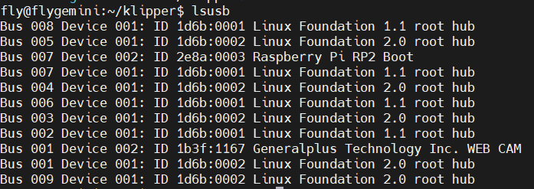

4. Configuration and testing
Tip
The installation method of accelerometer dependent package is as follows:
Tip
It is recommended to use SSH tools such as MobaXterm_Personal to operate
Tip
This step is for 非FLY上位机, if you are a Fly-πor Geminiseries, you don’t need to perform it! ! !
Execute the following three commands in sequence to install the accelerometer dependency package.
sudo apt update
sudo apt install python3-numpy python3-matplotlib libatlas-base-dev
~/klippy-env/bin/pip install matplotlib numpy
Please note that depending on the performance of the CPU it may take a lot of time, up to 10-20 minutes. Please wait patiently for the installation to complete. In some cases, the installation may fail if the motherboard has too little RAM.
- Open printer.cfg and add accelerometer configuration
[mcu adxl]
serial: /dev/serial/by-id/usb-Klipper_rp2040_XXXXXXXXXXXXXXXXXXXXX
### 查询usb固件id是：ls -l /dev/serial/by-id/
### 把/dev/serial/by-id/usb-Klipper_rp2040_XXXXXXXXXXXXXXXXXXXXX替换查询到的id

##ADXL345加速度计
[adxl345]
cs_pin: adxl:gpio9
spi_software_sclk_pin: adxl:gpio10
spi_software_mosi_pin: adxl:gpio11
spi_software_miso_pin: adxl:gpio12

[resonance_tester]
accel_chip: adxl345
probe_points:
100, 100, 20 # 此坐标为你需要测量的位置，一般为热床中间
- Save and restart after modifying the configuration
- Execute on consoleACCELEROMETER_QUERY
- Multiple accelerometers can be specified to test a certainACCELEROMETER_QUERY CHIP=bed
- If an error occurs, please check the wiring and configuration.
- The normal output is as shown below

- This way you can measure resonance.
- Remember to put everything back in place
- Test the X axis TEST_RESONANCES AXIS=Xand change the Y axis to Y as well.
Tip
Notice! If the printer vibrates too violently during the test, please press Emergency Stop or Send M112to stop it in time.
- If it is too high, accel_per_hzthe vibration will become severe, and it can be reduced appropriately.
[resonance_tester]
accel_chip: adxl345
accel_per_hz: 50 # 默认值为75
probe_points: ...

5. Automatic calibration
- klipper supports automatic calibration
- Remember to put everything back in place
- SHAPER_CALIBRATEAfter executing this command, the printer will start to automatically calibrate X, Y
- Executed after calibration is complete SAVE_CONFIGto save data
- It can also be used SHAPER_CALIBRATE AXIS=Xto automatically calibrate an axis,
- After each axis calibration is completed, the data must be saved before calibrating the next one.
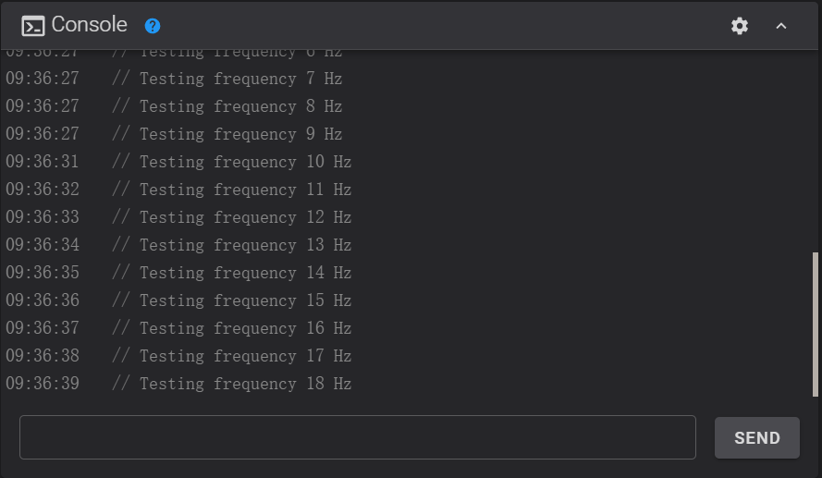
- The calibration process may take a long time, please be patient.

